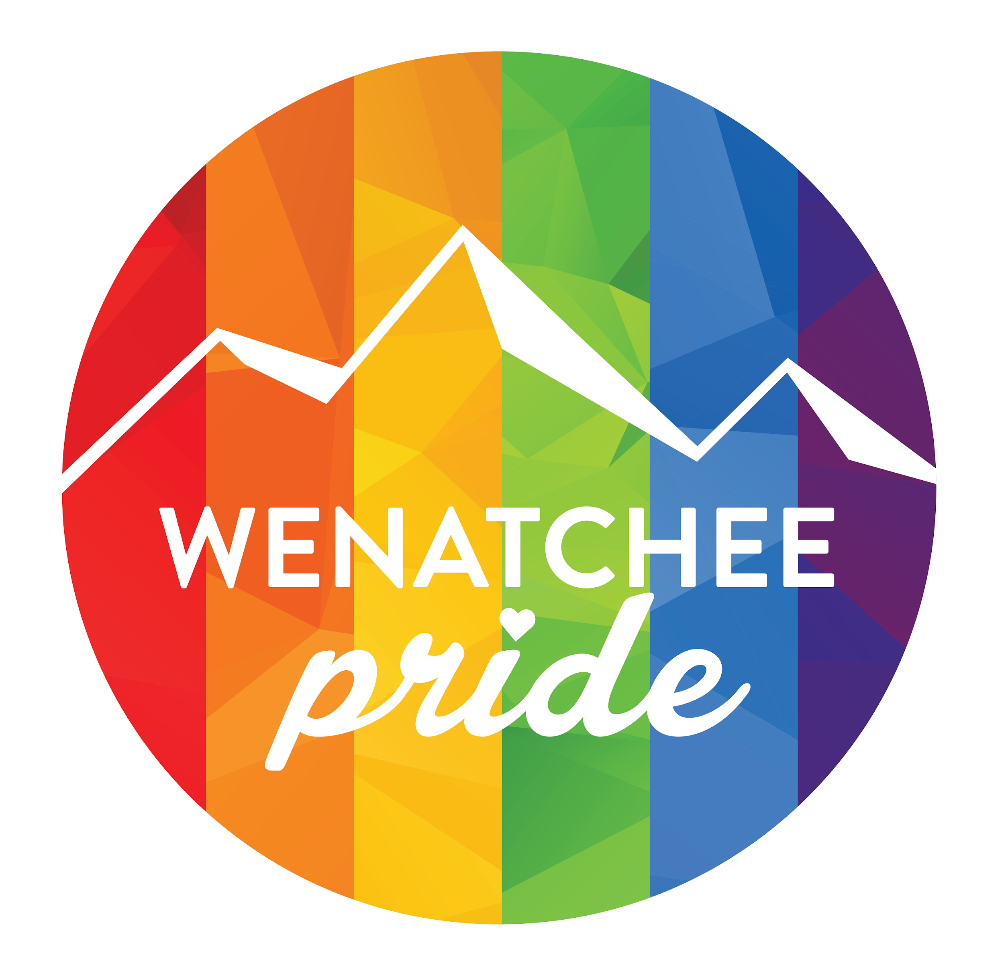

2019 Corporate Sponsorships
Wenatchee Pride - June 15th, 2019

In 2017, Wenatchee held its first ever Pride event at the Unitarian Church on Sunset Highway, East Wenatchee. Between 100-120 people showed up. The seed was planted, ready to grow into a bigger and higher profile event in 2018.

In 2018, over 1,300 of us joined together again to peacefully connect as a community of LGBTQ+ families and straight allies and to come together as one to show that love trumps all. For many, it was a time to connect with familiar faces in the LGBTQ+ community. For others, it was their first time coming out. For everyone, it was an opportunity to come together and realize, “we are not alone, we are supported, and we are loved.”

In our third year, we expect even more people! More vendors, more activities, more fun, more community. And we need our local community champions to help pull it all together.

We are raising funds to help with the costs associated with pulling off an event like this in Wenatchee. From rental fees, decorations, music, food, security, signage, flyers, prizes, websites and administration, there are a lot of moving pieces and many parts to organize and fund.

We have a lofty goal to raise $15,000*. We know that with the support of all of you, from businesses that believe in the power of community or organizations with LGBTQ+ employees, from family members and straight allies, we can get there. Help us by donating, by spreading the word, and by sharing this with every ally you can.

Help us make Wenatchee Pride 2019 an event to remember!

THANK YOU!! We appreciate your help!

*100% of funds (minus a small percentage payable to GoFundMe if you elect to pay via this method) will go towards the organizational costs of the event. Excess funds will be rolled over to the 2020 Festival and used to support local LGBTQ events, education, and outreach throughout the year.
WHAT IS LGBTQ+ PRIDE?
Gay pride or LGBT/LGBTQIA+ pride is the positive stance against discrimination and violence toward lesbian, gay, bisexual, transgender, queer/questioning, intersex, asexual, and all sexual orientations and gender identities.

This year, we honor the 50th anniversary of the events that led to modern-day Pride celebrations. Today, we celebrate Pride to promote the self-affirmation, dignity, and equal rights of LGBTQ+ people, increase their visibility as a social group, build community, and celebrate sexual diversity and gender variance. Pride, as opposed to shame and social stigma, is the predominant outlook that bolsters most LGBTQ+ rights movements throughout the world.

RECOGNITION OR ANONYMITY---YOUR CHOICE!
As shown below, we offer a lot of recognition at the higher sponsorship levels; however, we understand that you may wish to stay anonymous with your donation. If that is the case, you can elect to keep your donation completely private. Simply indicate your preference at the time of making your donation.

TAX-DEDUCTIBLE DONATIONS
Wenatchee Pride has partnered with the Cascade Unitarian Universalist Fellowship, a 501(c)3 nonprofit organization. Your donation is tax-deductible! EIN: 91-13603844

SPONSORSHIP LEVELS:

- RAINBOW SPONSOR
  - $3500 (1 available) (Taken! Thank you, Confluence Health!)
    - Listed as Presenting Sponsor
    - Logo at top of Wenatchee Pride website
    - Logo on marketing collateral (event posters, flyers, and event signage)
    - Logo on Facebook cover banner
    - Group thank-you on Facebook, Instagram, Twitter, and Snapchat
    - Free 6 ft. table/space at the Pride event for corporate literature/information
    - Dedicated Facebook post: Your business or organization highlighted in Facebook profile post on why your business supports the LGBTQ community (optional)
    - Dedicated Instagram post: Your business or organization highlighted in Facebook profile post on why your business supports the LGBTQ community (optional)
    - Your business listed as a dedicated event sponsor in Facebook’s “About” section
    - Your logo on Digital Billboard Advertising on Wenatchee Ave.
    - Speak at the Pride event (5 minutes on stage)
    - Recognition by emcee at the event (multiple times)
    - Logo on short-release event merch (tote bag, t-shirt, etc)
    - Recognition in all press interviews and advertising
    - Four free tickets to our after party, Out at Night, at the Highlander Golf Course

- PRISM PRIDE
  - $2500+
    - Logo on website
    - Logo on marketing collateral (event posters, flyers, and event signage)
    - Group thank-you on Facebook, Instagram, Twitter, and Snapchat
    - Free 6 ft. table/space at the Pride event for corporate literature/information
    - Your business listed as a dedicated event sponsor in Facebook’s “About” section.
    - Recognition by emcee at the event
    - Your logo on Digital Billboard Advertising on Wenatchee Ave
    - Logo on short-release event merch (tote bag, t-shirt, etc)
    - Three free tickets to our after party, Out at Night, at the Highlander Golf Course

- RED PRIDE
  - $1500-$2499
    - Logo on website
    - Logo on marketing collateral (event posters, flyers, and event signage)
    - Free 6 ft. table/space at the Pride event for corporate literature/information
    - Group thank-you on Facebook, Instagram, Twitter, and Snapchat
    - Recognition by the keynote speaker at the event
    - Logo on short-release event merch (tote bag, t-shirt, etc)
    - Two free tickets to our after party, Out at Night, at the Highlander Golf Course

- YELLOW PRIDE
  - $750-$1499
    - Logo on website
    - Business name listed on the event poster
    - Free 6 ft. table/space at the Pride event for corporate literature/information
    - Group thank-you on Facebook, Instagram, Twitter, and Snapchat
    - One free ticket to our after party, Out at Night, at the Highlander Golf Course

- GREEN PRIDE
  - $500-$749
    - Business name listed on the website
    - Business name listed on the event poster
    - Group thank-you on Facebook, Instagram, Twitter, and Snapchat

- BLUE PRIDE
  - $250-$499
    - Business name listed on the website
    - Business name listed on the event poster

HOW TO DONATE?

Visit our GoFundMe page to make an electronic donation:
https://www.gofundme.com/wenatchee-pride-2019

To send a check, please mail it to:
Wenatchee Pride
P.O. Box 3242
Wenatchee, WA 98801

Please make out all checks to: “CUUF”
Write “Wenatchee Pride” in the memo area

CONTACT
Get in touch with Wenatchee Pride to learn more about the event and how you can get involved. We are currently in the planning phase of the event. To make suggestions, or follow along, check in with our Facebook page regularly (www.facebook.com/wenatcheepride). Alternatively, feel free to email the planning committee with your ideas and suggestions. If you can’t sponsor at a corporate level but would like to contribute in-kind goods and services, please reach out to pridewenatchee@gmail.com or by visiting www.wenatcheepride.com

With your help, we will make this event a positive experience for everyone!

